Migration Strategy & Execution Plan
aftermarketdbx — Synapse to Databricks, Wave-Based Rollout
All pipeline/view counts in this document are approximate and will be confirmed during Discovery.
Version 1.0 | 2026-09-21

Table of Contents

1. Purpose & How to Read This Document
This document lays out the migration strategy for moving aftermarketdbx off Synapse onto Databricks: current vs. proposed architecture, how the inventory is being built, how tables/pipelines get prioritized into waves, and how each wave moves from build through to cutover. It is meant to be read alongside the DE Standards & Governance document — this covers the how-and-when of the migration itself, not the ongoing engineering standards.
- All pipeline, view, and table counts here are approximate and will firm up during Discovery (Section 4) — treat every number as directional, not committed.
- Wave sizes and durations are planning assumptions, refined after the Pilot.

2. Current State vs. Proposed State

2.1 Current State — Synapse
SAP GUI exports land on a network drive, an Auto Loader job picks them up into Azure Storage, Synapse pipelines run Python transforms into Silver parquet files, and analysts query views built with OPENROWSET directly on top of those files.

2.2 Proposed State — Databricks
BIS extracts source systems (SAP, CIO, and others as onboarded) into their own prod_silver tables — treated as our raw input. DE runs a readiness check on each table: if it's in good shape, Gold is built as a materialized view directly on top of it; if not, DE curates its own Silver first. Either path lands in Gold for analyst consumption.
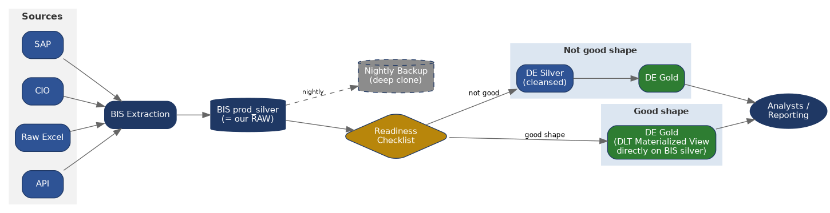
Full detail on both layers, the readiness checklist, and the data contract standard are in the DE Standards & Governance document, Sections 3.1–3.7.

3. Inventory Snapshot (Approximate)
Approximate — confirm in Discovery: all figures below are current best estimates pending full Discovery confirmation (Section 4).
Item | Approx. count | Notes
Total pipelines | ≈ 130 | Includes dormant/unused pipelines
Active pipelines | ≈ 97 | Ran at least once in the recent monitoring window
Dormant pipelines | ≈ 33 | Not currently running — candidates to confirm as retire-not-migrate before Wave 3
Total views | ≈ 208 | Built on Silver parquet via OPENROWSET
Top active views identified so far | ≈ 97 | By query frequency — remainder still being profiled
Dormant pipelines and low/zero-usage views are not automatically excluded — each is confirmed one by one (owner check + a last-mile usage look) before being dropped from scope, and any confirmed-needed ones fall into Wave 3 rather than being migrated early.

4. Five-Stage Migration Approach
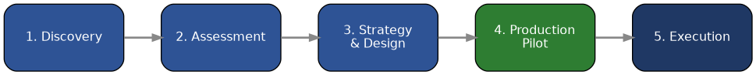
Stage | What happens
1. Discovery | Build the complete inventory and lineage (pipeline → silver → views) and capture real usage — this stage produces the numbers in Section 3.
2. Assessment | Classify every pipeline/view by business impact, usage, and technical complexity (Section 5's priority formula) — output is the wave assignment.
3. Design | Confirm target schema/contract per table, history pattern, and the good-shape-vs-own-silver build path per the Standards document.
4. Pilot | One real, end-to-end use case — smoke-tested, parallel-run, UAT'd, and cut over — to prove the pattern before scaling.
5. Waves | Repeat the proven pattern at scale: Wave 1 → Wave 2 → Wave 3, each following the same stage-gate flow (Section 6).

4.1 Discovery Method
Discovery combines automated evidence with manual DE review — neither alone is reliable:
Method | What it covers
System query (automated) | Pipeline run history (success/failure, last-run date) from Synapse monitoring; view query frequency and distinct callers from query logs / Log Analytics where available. Produces the raw active/dormant and top-queried numbers.
Manual review (DE) | Confirms what the logs can't show: whether a "dormant" pipeline is genuinely dead vs. quarterly/seasonal; whether a low-query view is still relied on by a report that queries infrequently but matters (e.g. year-end); tribal knowledge not captured in any log.
Every pipeline/view gets both — system query gives the first pass, manual review is the confirmation step before anything is dropped from scope or assigned to a wave.

5. Priority Formula & Wave Assignment
Wave assignment is scored, not guessed — each pipeline/table gets a score combining business impact, usage, and complexity, then waves are cut by score band. This avoids the trap of front-loading Wave 1 (which doubles as the Pilot's proving ground) with the hardest items just because they're also the most critical.

Scoring formula
Priority Score = (0.40 x Business Impact) + (0.35 x Usage Score) - (0.25 x Complexity Score)

Business Impact (1-5): revenue/compliance/exec visibility if this breaks or is delayed
Usage Score (1-5): query frequency + distinct consumers (from Discovery)
Complexity Score (1-5): transformation logic, dependency count, data quality issues

Score > 3.0 -> Wave 1 candidate (Pilot drawn from the top of this band)
Score 1.5 - 3.0 -> Wave 2
Score < 1.5 -> Wave 3
Usage = 0 AND dormant -> Confirm for retirement before any wave assignment

Worked example
Table/Pipeline | Impact | Usage | Complexity | Score | Wave
gold_stock_on_hand | 5 | 5 | 2 | 3.65 | Pilot / Wave 1
gold_vendor_master | 4 | 3 | 2 | 2.55 | Wave 1
gold_procurement_detail | 3 | 2 | 4 | 1.5 | Wave 2
rarely-used regional view | 1 | 1 | 1 | 0.75 | Wave 3 (or retire)
Weights (0.40 / 0.35 / 0.25) and the band cut-offs are starting assumptions — tune them after scoring the first real batch in Assessment, and revisit after the Pilot.

Wave sizing
Stage | Approx. size | Selection logic
Pilot / smoke test | ≈ 1 pipeline chain, ≈ 3–8 dependent views | Highest-scoring item that is also end-to-end-representative — proves the pattern, not the hardest problem.
Wave 1 | ≈ 10–15 pipelines, ≈ 20–40 views | Top of the Wave 1 score band — high impact, moderate complexity. Small enough to reconcile properly while the team is still learning the framework.
Wave 2 | ≈ 30–40% of what's left | Mid score band — reuses the framework/contracts/CI-CD built in Wave 1, so throughput should be faster per item.
Wave 3 | Remainder, plus any dormant items confirmed as still needed | Lowest score band, plus anything reclassified out of "retire" after manual confirmation.

6. Stage-Gate Execution Flow (per table, every wave)
Every table — pilot included — goes through the same five gates. The Pilot gets more scrutiny and a longer parallel-run window because it's also proving the process, not just the data.

6.1 Parallel Run Strategy
The new Databricks pipeline runs alongside the still-live Synapse one; length of the window matches the report's own cadence rather than a fixed number of days:
Report cadence | Suggested parallel window | What's compared
Daily operational (e.g. Stock on Hand) | ≈ 1–2 weeks of daily runs | Row counts, business-key completeness, hash-based row comparison
Monthly/quarterly close-driven (e.g. Finance GL) | At least one full close cycle | Full reconciliation through an actual close — can't be shortcut, it's the only way to see close-time behavior
Ad hoc / low-frequency | Next 2–3 natural refreshes, whenever they occur | Same checks, just spread over a longer calendar window

6.2 UAT
- Analyst/business owner named in that table's Data Contract signs off — confirms the numbers match what they expect, not just what the old system produced.
- An issue found in UAT routes back to Parallel Run (Section 6, dashed line) rather than straight to a hotfix — re-reconcile before re-attempting sign-off.

6.3 Cutover
- Repoint the consuming report/BI tool to the new Gold table only after UAT sign-off is recorded.
- Pause (don't delete) the old Synapse pipeline for a rollback window after cutover — cheap insurance, and it gives stakeholders confidence while the new platform proves itself under real use.
- Decommission the paused Synapse object only after the agreed rollback window passes with no issues.

7. DevOps Board & Delivery Visibility
Same Epic → Feature → User Story → Task hierarchy as the Standards document, with Features aligned to source system so both source-based and wave-based views are possible from the same backlog.
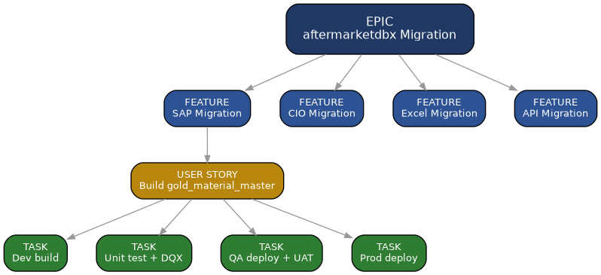

7.1 Migration Tracking Board
In addition to the normal sprint board, a wave-tracking board view gives leadership a single glance at progress through the stage gates:
Discovery | Assessment | Pilot/Build | Parallel Run | UAT | Cutover
gold_x (new) | gold_y | gold_stock_on_hand | gold_vendor_master | gold_material | gold_gl_summary
Each card = one table/pipeline; moving right = moving through Section 6's stage gates. Gives a wave-level burn-up at a glance without opening individual sprints.

7.2 Delivery Cadence
- Suggested: each wave runs as a set of 2-week sprints; Wave 1 sized to roughly 3–4 sprints including its parallel-run windows, refined after the Pilot's actual timing is known.
- Wave retro after every wave — feed timing/complexity-scoring adjustments back into Section 5's formula for the next wave.
- Burn-up reported at the wave level (tables through Cutover / total in wave) rather than story-point velocity alone, since stakeholders care about tables live, not points closed.

8. Appendix — Diagram Source (Mermaid)
Rendered versions appear in Sections 2, 4, 5, and 6. Mermaid source given here and as separate .mmd files.

A.1 Current State (Synapse)
flowchart LR
SAP[SAP GUI Export] --> DRIVE[Network Drive] --> AL[Auto Loader Job] --> BLOB[(Azure Storage)]
BLOB -->|~130 pipelines, ~97 active| SYN[Synapse Pipelines - Python transform]
SYN --> SILVER[(Silver Parquet Files)]
SILVER --> VIEWS[Views - OPENROWSET - ~208 views]
VIEWS --> ANALYSTS[Analysts]

A.2 Wave Sizing & Pilot Flow
flowchart LR
PILOT[Pilot / Smoke Test - ~1 chain, ~3-8 views] --> WAVE1[Wave 1 - ~10-15 pipelines, ~20-40 views]
WAVE1 --> WAVE2[Wave 2 - ~30-40% of remaining]
WAVE2 --> WAVE3[Wave 3 - remainder + confirmed dormant]
WAVE3 -.if confirmed dead.-> RETIRE[Retired / Not Migrated - ~33 dormant to confirm]

A.3 Stage-Gate Execution Flow
flowchart LR
CODE[1. Code Smoke Test - CI] --> DATA[2. Data Smoke Test - QA]
DATA --> PARALLEL[3. Parallel Run - Reconciliation]
PARALLEL --> UAT[4. UAT Sign-off]
UAT --> CUTOVER[5. Cutover]
CUTOVER --> PAUSE[Synapse Paused - rollback net]
UAT -.issue found - back to parallel run.-> PARALLEL

Draft for discussion. Figures and wave boundaries firm up after Discovery and the Pilot retro.

